

Name/ID : ABDELKAREEM YOUSEF MAMDOH SOUBAR/19110022
Subject :Managing a Successful Computing Project
Assignment Title :mid term
Submission Date : 3/12/2022

digital transformation
what is digital transformation ?

It is hard to show digital transformation in a company because every company may have a different way of implementing it in their field, so basiclly its the result of integrating digital technology in all areas of a company/business and the effect shows by the change that happens in the process of operating the company and delivering to the customer.

Carry out a preliminary study to understand the concept of the environmental impact of digital transformation.

digital transformation will impact all companies in multiple different ways and methods, plus having a company fully digital would make the prosses in a company much simpler and faster which means more efficient and less time-consuming and uses fewer resources.

Also, I have to talk about the drawbacks of using digital technology in general where here I have to mention the impact mainly on the environment, and by that I mean E-wast that is going to happen that is by using/ manufacturing devices that would use less power and develop them but along the process, the environment would suffer by leaving more of the carbon footprint by using more devices that use energy and everybody would produce more energy than before plus having more and more devices around the world.

But I have to also talk about how investing in the development of those devices would make them more energy-saving/efficient plus it encourages the mother companies to keep on developing them to fewer producers of e-wast.

Provide a detailed insight into the potential of refurbishing, repairing and, reusing digital devices rather than replacing them.

Nowadays the devices are getting smaller and much stronger than ever before and a lot of people are starting to replace their old devices with new ones so they would take the load and be more effecnt by sating updates on the marketplace.

Staying updated on the marketplace is, of course, important to stay updated but you don’t have to through away the old devices, because at the moment most of the services are trying to become lighter on devices al thought the devices are getting stronger, and a lot of the services nowadays only need a browser to function, which means that we can start reusing the old devices without having any sort of a problem because most of the old devices may have enough power to open and use a browser such as chrome os.

Reusing old devices would mean having less carbon footprint on the world because not all e-wast is recyclable, but the updated devices are more recyclable than before because a lot of the companies are getting encouraged on developing devices that are greener than before without losing on any part of the functionality.

Data process now is mostly on the cloud services where if you are using your new or old devices, it wouldn't have much effect on the user experience that you are going to face when using the product and the world is heading towards that user using less energy and most of the energy consumption is coming from one place that is the services provider(cloud services) it means that your devices would need to process much or have much storage only good internet connections such as Netflix and Spotify.

Investigate what kind of devices can be utilized or the technology can be used to be installed in the old devices to reuse them.

The main focus here comes on what most people have in their hands at the moment plus having small group communities that are looking at how to reuse old devices that are not common in those days such as PDAs.

But here I will be mainly talking about what most people have such as smartphones, old laptops /personal computers.

Smartphones are one of the biggest things on the list because almost the enter would have at least one smartphone around and that would mean that it is very important to focus on them and how to reuse them.

It all starts by breaking the problem into small pieces, without going into details old smartphones may suffer from having low-resolution screens and not being able to have a lot of process power which made them harder to use, this is where cloud computing comes in in in in handy by having the procces being processed in the company and the phone only has to show the results, by that phone would need to use more power plus it is more secure to use the services like that and it enables the old phone to more usable in multiple different directions.

Old laptops / personal computers are usually suffering from low performance, but to get them more on their feet you can upgrade some components from the hardware so they would become more suitable plus they can be used in multiple different directions such as reusing old computers as storage server in a house or be the device that is used in a smart house and chrome os is available and it is very lightweight and it can be used on almost any old device and make it more functional.

Part 2 - Identifying an organization Describe the work that you did to select an organization for your project. Which organizations did you contact? Include the text of the email or message that you sent to them. Include their responses.

Royal Jordanian Airlines it's an airline company that contains multiple different departments and it has the capability of fixing an airplane through there engineering department they also can sell tickets and they have an IT department to maintain there website and services.

They can be included in the digital transformation because their late project was to book online instead of going to the main company and now they don’t use paper in the process.

In summery
here we talk about the general idea of digital transformation's impact on the world and companies and it shows how using old devices may make the processes better, and it shows that old devices can be used with new technology it just needs a little bit adjustment that's all.

survey

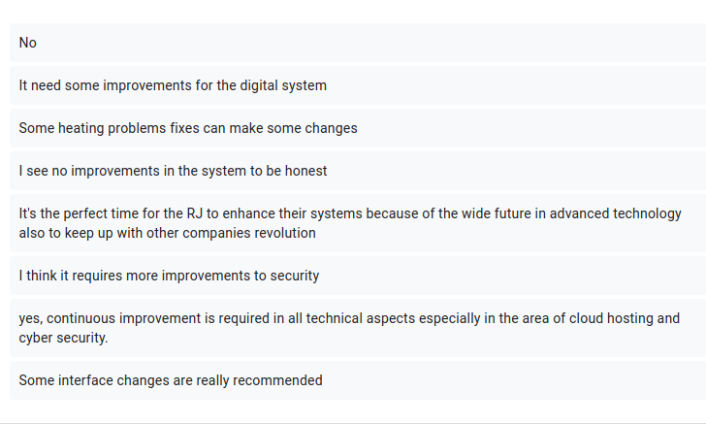

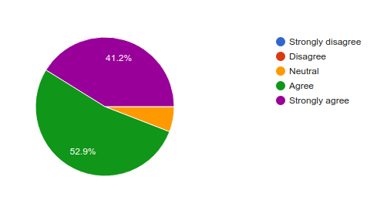

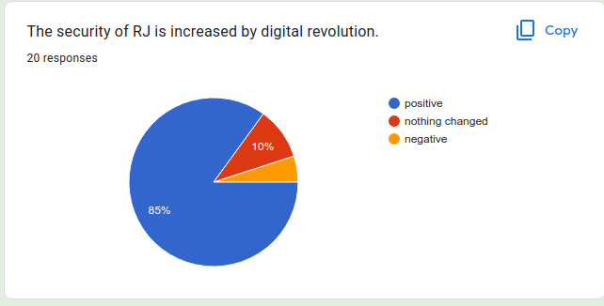

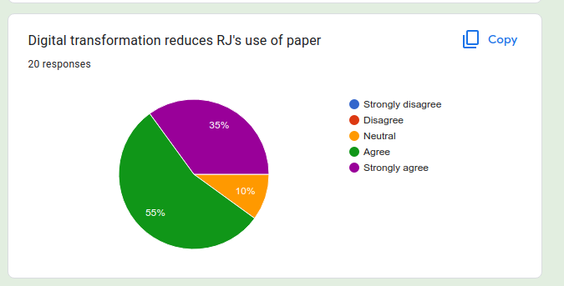
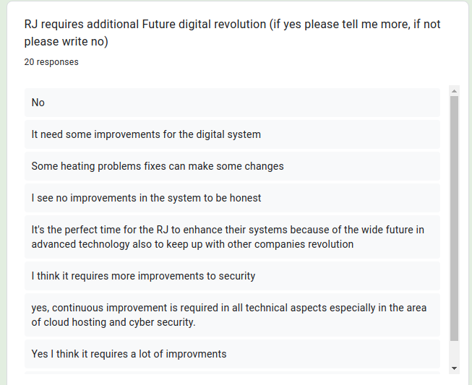

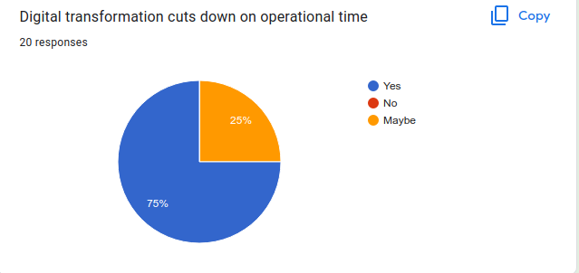

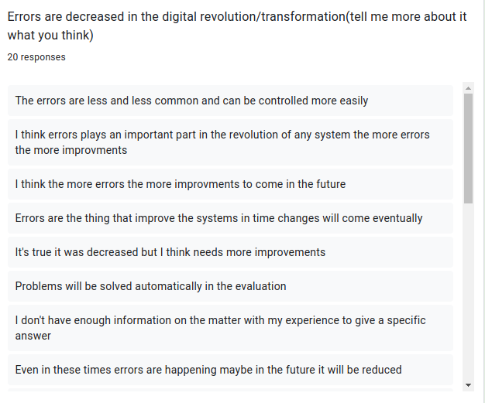

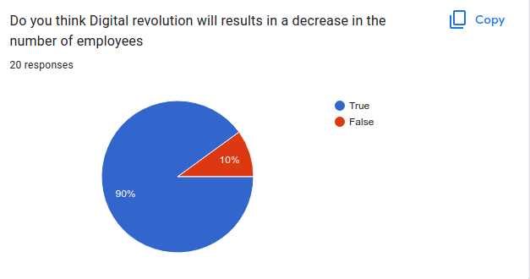

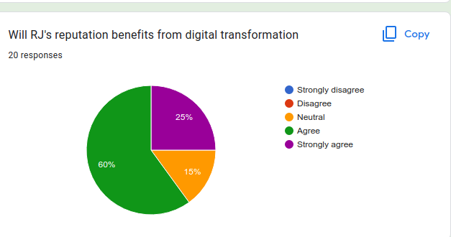

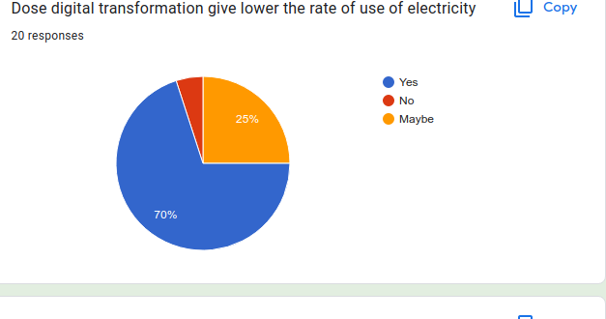

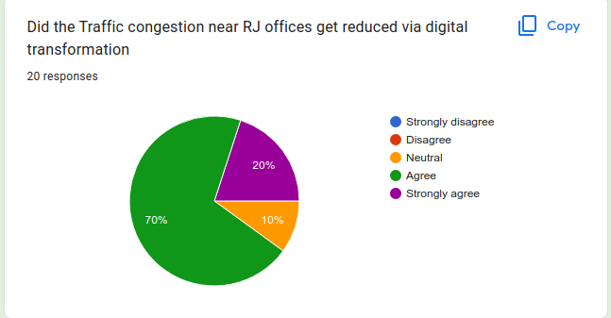

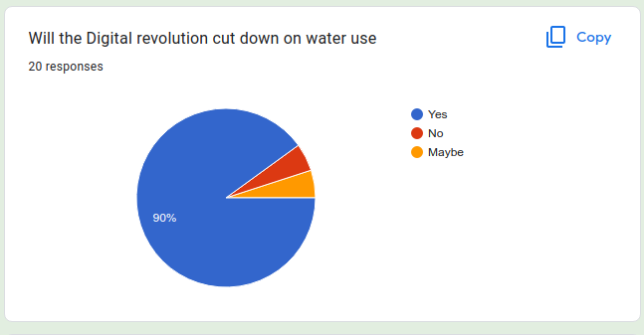

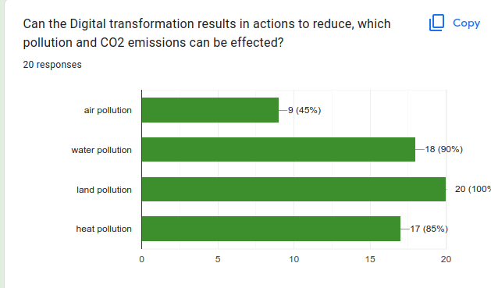

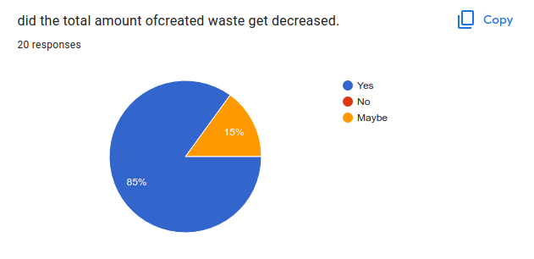

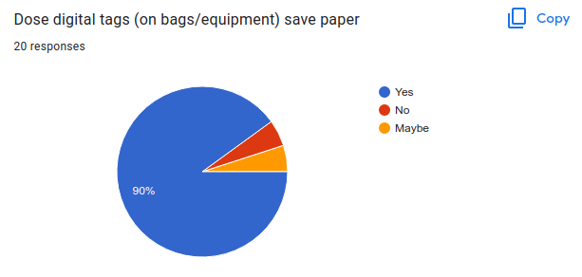

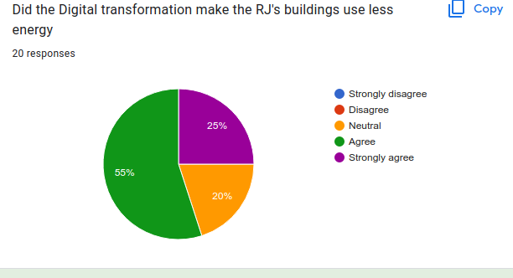

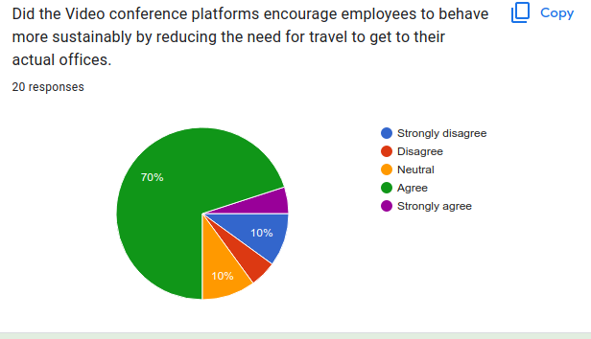

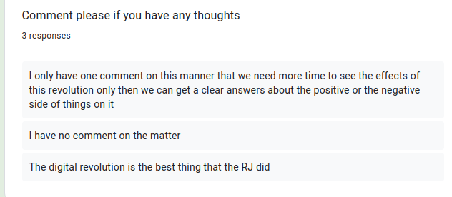

summery

in summery this survey talks about how well is the RJ doing in the felid of using technology for there customers and how well are they adopting the digital transformation method’s in the company and it al so tells me what sort of ideas I can suggest plus I had called them about this subject and they told me that some place in the organization are left from before with out upgrade such as the check in system in the airport plus in the main build they have the appointments manually scheduled on paper and they don’t have a work from home stable system this where my ideas are going to come from and this where I set my mind set with them

organization study

our organization is royal Jordanian airline (RJ) is an LTD company it connects Jordan with the would providing a high level of safety security and reliability

operational areas
- corporate HR
it is responsible for managing the employee’s life cycle, features Hiring new employees training them – employee-rs relationships (including compensation, benefits and promotions ) and firing/laying off employees
- cargo
it is responsible for managing mail careers package delivery services handling shipments and storing them according to standard operating procedures
- finance
compliance with accounting and financial standards and consolidation with the financial data, ensuring the proper execution of strategic planning process the profatability of the company to maximize profit
- engeneraing and maintenance
responsible for aircraft planning and under taking scheduled maintenance repairing equipments and aircraft, and installing new aircraft technical programmers
- airport services
carryout passengers check-in process with accordance to security and safety regulations handel passengers baggies and print boarding passes , and ensure that passengers have a proper documentation on boarding the plain

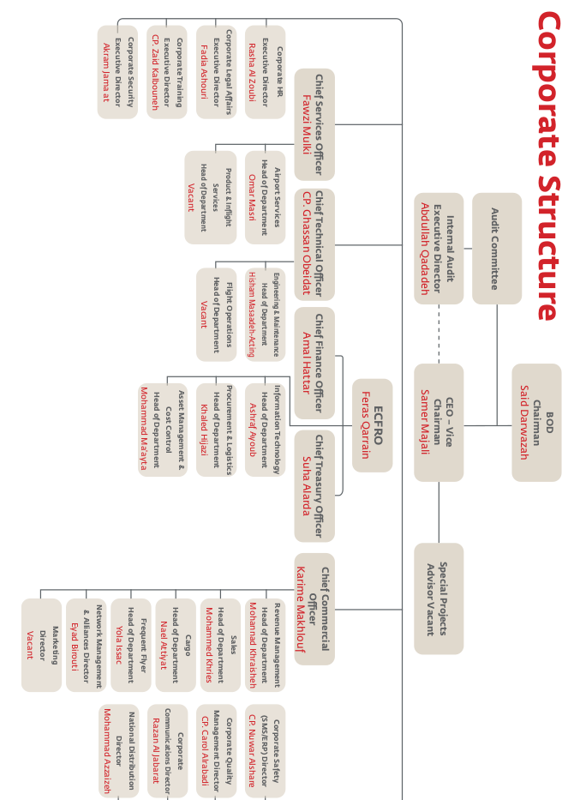

stakeholders (internal and external)

Stakeholders internal | Roles
Employees | They effect the company's performance and have health and safety focus plus to ensure that they continue to be paid
Bored of directors | The future of the company depends on what the Bored of directors say

Stakeholders external | Roles
Suppliers | They are responsible for getting the equipments and maintenance such as parts for airplanes
Government | They have the hightest percentage of the shares in the company and that gives them the power to have digestion making rights
Travel agents | Its responsible for having a huge increase in the number of passengers
Government regulations | They effect the company by creating new rules / editing / changing
communities | Places the ideas where to go and how to keep up to expectation

Challenges
the company deals with various types of challenges with a comprehensive framework with risk managements in accordance with the best international standards and practices.
Challenges may be summarized as follows
- operation discontinuation
the world continue from economic effects of Covid pandemic on the performance of the company around the world and decrease the number of people that want to travel, the company made plans and measurements to make sure that this decrease of demand that happened wont effect the company

- geographical location
the location of the kingdom creates a big challenge to the company specially these days when political and economic attentions is occurring I some nearing Arab countries the company has to adopt and its operation with these difficult changes
- market changes
the completion of the airlines had been increasing lately because of low-cost airlines to meet this channel RJ has prepared short and long-term strategies to limit this effect through improving the standards of services provided, increasing passenger satisfaction, simplify travel procedures, provide more travel choices as a member of one world alliance
- Fluctuation of fuel prices
The cost of fuel constitutes a large and escalating part of the company’s operational expenses.
It amounted to 23% of the total operational expenses for the year that ended 31.12.2021. As
such, any material change in the price of crude oil and subsequently the price of jet fuel could
affect the operational results of the company substantially. In this field, RJ has taken steps
to deal with the rising fuel prices through imposing a fuel surcharge on tickets, focusing
on increasing passenger numbers, managing revenue and maximizing the yield. This is in
addition to entering into fuel hedging contracts, which is international best practice for air
carriers in this field.
- Cybersecurity
Data protection is one of the most important pillars of digital transformation, as the company
needs it to detect any threats in a timely manner, in addition to ensuring the continuity of RJ’s
operations and supporting its business objectives, and in light of the impact of the COVID-19
pandemic, Royal Jordanian has succeeded in implementing a platform for detecting and
responding to any security issue through one of the best leading companies in this field.
- The procedure used to implement changes required in the company there are steps to implement such changes
RJ uses a software for change management and RJ employees use this system by making request in the system according at the right information
The system contains all the attributes in the system that need to be changed and it goes through the process of getting approval's from all people and creates arrangements with customers
any other change management required it goes through the bored of directors tregaery department is used to inform share holders about any change that would happen or appear and keep theme in touch and it produces the annual financial report

organization requirements

- Vision...
To be the airline of choice, connecting Jordan and the Levant with the world.
- Mission...
To ensure that our customers always recommend our airline, because we consistently
- provide:
The highest levels of safety, security, and reliability.
A seamless travel experience with exceptional customer care.
Value for money through maintaining cost efficiency.
To ensure that our people are motivated and work productively as a team, because we
- offer:
A healthy and stimulating work environment with open dialogue and participation.
Competitive employment benefits and rewards.
Opportunities for training and career development.
Energetic and decisive leadership.
To ensure that our shareholders invest in the company, because we deliver:
Promising future.
Sustainable growth.
The highest levels of corporate integrity and responsibility.
To ensure that our country is proud of us, because we:
Represent the best of Jordanian hospitality and culture.
Promote Jordan as a destination and a gateway to the Middle East, for both business and
leisure travelers.
Support local communities and charities.
- Values...
We strive for excellence and those who succeed in our company will be team players.
We enjoy working and succeeding through effective communication and believe we can
achieve more by working together as one team.
We respect people’s opinions and learn from our differences.

- Objectivity...
We make decisions based on solid facts and robust business cases, not on emotions or
opinions.
We always provide data to make our point and convince our colleagues.

- Reliablility...
We constantly endeavor to provide customers with their needs.
We guarantee strict compliance with the company’s internal policies and external
regulatory requirements.

- Commitment...
We are dedicated to delivering the best to our stakeholders.
We set and achieve high-performance standards.
We take responsibility for our actions and our work.
We listen and respond to both our internal and external customers’ needs.

- Care...
We are always understanding and helpful towards our customers.
We always try to be supportive and accommodating to our colleagues.
We aim to deliver standards to others that we wish for ourselves.

- Trustworthiness...
We are always honest and transparent with our customers, partners, and employees.
We nurture trust and respect in our working environment, and promote an atmosphere of
open communication.
- Capital Investments
The value of Royal Jordanian’s property and equipment amounted to JD60 million in 2021,
compared to JD73.9 million at the end of 2020, a decrease of JD13.9 million; this is the result
of a general depreciation of JD21.4 million, in addition to the purchase of equipment and
property at a value of JD7.5 million, including cash additions at a value of JD6.8 million.

Screen shots from the email for approval and survey

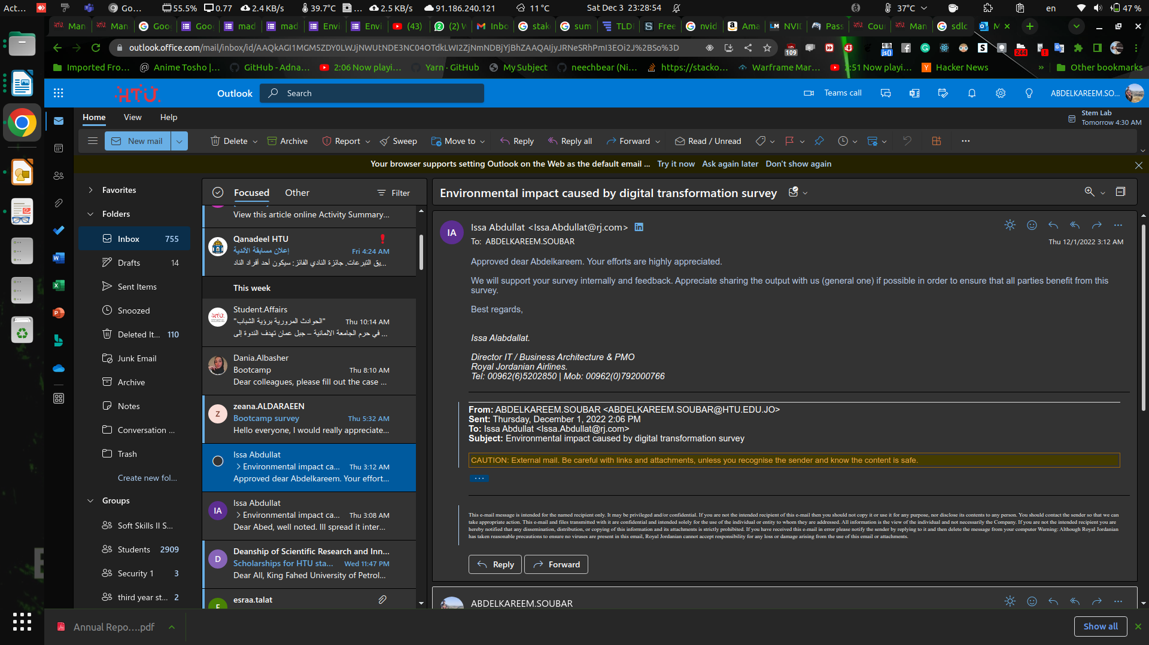
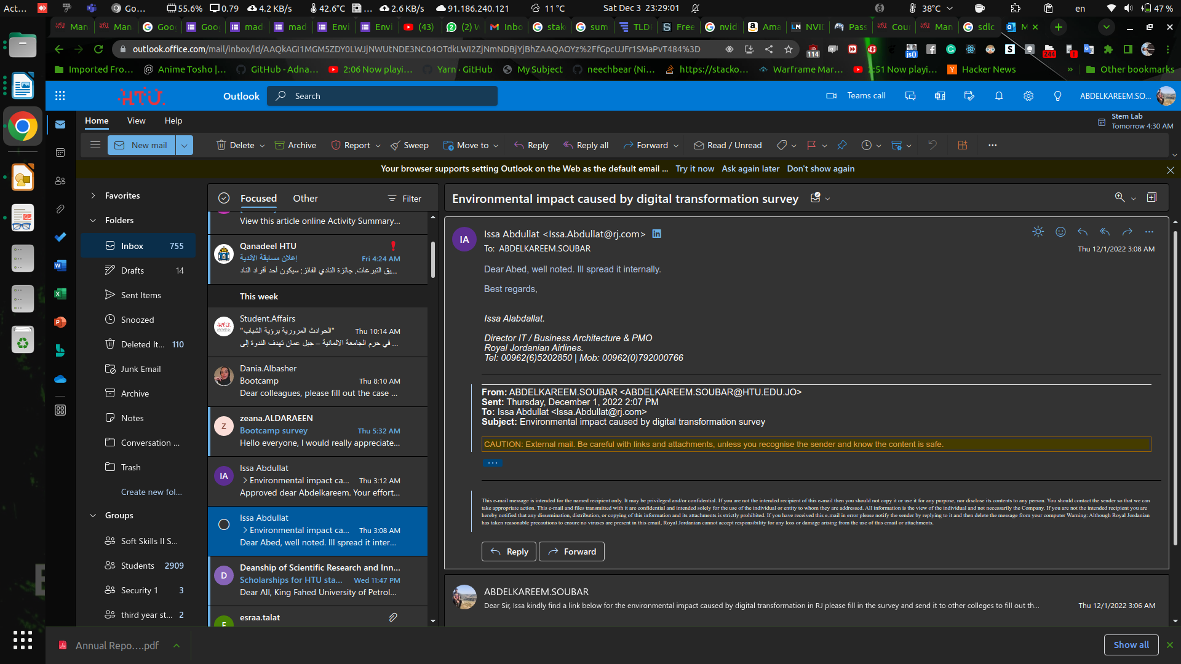

PROJECT TITLE | RJ’s research
SUBMITTED BY | Abdelkareem sober | PROJECT TYPE | Computing
PHONE / EMAIL | 0789266566/sobaerkareem@gmail.com | TOTAL ESTIMATED BUDGET | 53,000.0
DATE OF PROPOSAL | 3/12/2022 | VERSION NO. | 1
PROJECTED START DATE | 12/12/2022 | PROJECTED COMPLETION DATE | 8/9/2023

Project Proposal
Stakeholders:
PROJECT SPONSOR Commissions delivery of and champion’s project; Provides vision and direction; Accepts responsibility
- we need to talk about which sort of sponsers do we need as a start am going to talk about government suporrt because they are the biggest shareholder in the company
- now we need to talk about kaisen and there it security department plus a security company such as fortinet
- we may need some amazone supoerrt /sponser because we need there servers here for the implementaion part

PROJECT MANAGER Confirms need for project and validates objectives; Provides specs, monitoring, and overall delivery
You need to discuss the role of project manager and it’s impact on the success of a business.
Project manager needs to be more open minded about this because the project we are talking about need a lot of IT power and the IT teams needs to experienced for minimum BUGS plus he needs to be very knowledgeable and able to let other departments adapt with the change that's going to happen.
And now the project's manger also needs to be experienced with talking to people and letting them under stand how everything work

ADDITIONAL STAKEHOLDERS
STAKEHOLDER NAME | STAKEHOLDER ROLE | STAKEHOLDER IMPACT | CONTACT INFO
amazon | Provide global services | Has a global services for the company
Government | regulations | Be sure that each country allows what we are doing
employees | Building the system | They are the people that are going to build the system
Management and the bored | Support | They will manage and talk about the flow of the project
PROJECT OVERVIEW
SUMMARY
This idea is about the impact that would change when we implement digital transformation on a larger area from the company and here we would do that by creating an appointment system for the clinic in side the RJ and create a system in the RJ to be able to work from home and be effective as if the person was in the company it self and in both scenario we would use less people and fo the second one we would have less people coming in to the build which means less water and electricity by using less air conditioning system and have a more space in the building to do other project's

BUSINESS JUSTIFICATION
This result that I got is based on what my survey reported to me plus me calling them to under stand more, and the thing I got is that a lot of the departments had ben upgraded but still many of them need planing before implementing digital transformation, and this is where i come to plan and design plus think about how this project flow would go

PROJECT OBJECTIVES
The objectives are to make RJ more green by using digital transformation to make the operations fast and more easy on the customer by auto mating few features in the company it self plus having the employees more rested by creating the system work from home.

DELIVERABLES
You need to specify project deliverables and methods of implementation of change.
At the moment
planing
Define Requirements
Design and Prototyping
Software Development
Testing
Deployment
Operations and Maintenance

EXECUTIVE DECISION RECORD
DATE | APPROVED BY | DECISION

References

Dallemand, Julien. “Is Digital Transformation the Key to Environmental Sustainability in Logistics?” Blog.datumize.com, blog.datumize.com/digital-transformation-and-environmental-sustainability-in-logistics.

“Data, Digital Technology, and the Environment.” Www.genevaenvironmentnetwork.org, 25 Nov. 2021, www.genevaenvironmentnetwork.org/resources/updates/data-digital-technology-and-the-environment/.

Environment, U. N. “Digital Transformation.” UNEP - UN Environment Programme, 24 June 2021, www.unep.org/explore-topics/technology/what-we-do/digital-transformation#:~:text=Early%20analyses%20suggest%20the%20benefits.

“Home - Royal Jordanian.” Rj.com, 2019, www.rj.com/.

Junge, Anna Lisa, and Frank Straube. “Sustainable Supply Chains – Digital Transformation Technologies’ Impact on the Social and Environmental Dimension.” Procedia Manufacturing, vol. 43, 2020, pp. 736–742, 10.1016/j.promfg.2020.02.110.

Kunkel, Stefanie, and Marcel Matthess. “Digital Transformation and Environmental Sustainability in Industry: Putting Expectations in Asian and African Policies into Perspective.” Environmental Science & Policy, vol. 112, Oct. 2020, pp. 318–329, 10.1016/j.envsci.2020.06.022.

Mohamed, Abdelmenam. Key Environmental Challenges & Opportunities from Digital Technologies in West Asia.

Nguyen, Nguyen Phong, and Tu Thanh Hoai. “The Impacts of Digital Transformation on Data-Based Ethical Decision-Making and Environmental Performance in Vietnamese Manufacturing Firms: The Moderating Role of Organizational Mindfulness.” Cogent Business & Management, vol. 9, no. 1, 22 July 2022, 10.1080/23311975.2022.2101315.

Thompson, Barry. “The Environmental Impact of Digital Transformation in Manufacturing.” Blog.kerridgecs.com, blog.kerridgecs.com/digital-transformation-in-manufacturing.

Truong, Thanh Cong. “The Impact of Digital Transformation on Environmental Sustainability.” Advances in Multimedia, vol. 2022, 17 May 2022, pp. 1–12, 10.1155/2022/6324325.

